### UHI_Logo_CMYK_Sm

**Responsive Web Design Practical Assessment – Report Template  
HND Computer Science**

|  |  |  |  |
| --- | --- | --- | --- |
| **Module Code/title:** | H1J9 35 Developing Websites for Multiplatform Devices  HF57 35 Web Development: Dynamically Generated Content | | |
| **Module code**: | H1J9 35 / HF57 35 | **Word-count:** | N/A |
| **Date due/time:** | Friday 18th March 2022 11.59pm | **Date submitted:** |  |
| **Student candidate Name:** | Calum Lindsay | | |
| **Student ID:** | 21010093 | | |

**Completing your assessment:**

You must submit all documentation in the appropriate Network & Information Security assessment folder on the VLE. The name the file should be **studentid\_web2.docx**. So for example, if your Student Id is: 0123456 then the file name will be 0123456\_web2.docx

**Declaration of originality and authorisation to hold this assessment electronically and verify that it is original:**

UHI recognises that plagiarism, where deliberately engaged in, is unacceptable and is considered serious academic malpractice. **Students are responsible for ensuring the work they submit is their own**. If you have any queries you should contact your Tutor or Student Adviser before submitting your assessment.

**By submitting this assessment I declare that the attached piece of work is my own**. I have acknowledged all the sources I have consulted and where I have used words which are not my own, I have clearly indicated this in the references.

|  |  |  |  |
| --- | --- | --- | --- |
| **Student ID:** | 21010093 | **Date:** | 03/03/2022 |
|  | | | |
| **Lecturer Feedback:**  **Date:** |  | | |

# Music Online – Assessment Planning, Implementation and Testing

# Checklist

|  |  |  |  |
| --- | --- | --- | --- |
|  | **DESIGN Checklist** | **LO Element** | **Date Achieved** |
|  | Provide an overview of the main web site. | DWM LO2 | 25/01/2022 |
| 1 | Identify functional website requirements. | DWM LO2 | 26/01/2022 |
| 2 | Identify non-functional requirements.  (constraints) | DWM LO2 | 26/01/2022 |
| 3 | Who are the target audience. Admin & Users | DWM LO2 | 27/01/2022 |
| 4 | Developer requirements: Hardware, Software, Server Software | DWM LO2 | 28/01/2022 |
| 5 | Project Schedule of expected/actual completion of major tasks | DWM LO2 | 25/01/2022 |
| 6 | Site Map | DWM LO2 | 27/01/2022 |
| 7 | Storyboard layout of min 2 viewports | DWM LO2 | 28/01/2022 |
| 8 | Summary description of pages | DWM LO2 | 30/01/2022 |
| 9 | Database Design/Data Dictionary | WDD LO2-4 | 01/02/2022 |
| 10 | Explain Test Strategy to be used | DWM LO2 | 19/02/2022 |
| 11 | Create a Test Plan.  Expected & Actual Results.  Any actions taken.  (Responsiveness test in different browsers) | DWM LO2 | 20/02/2022 |

|  |  |  |  |
| --- | --- | --- | --- |
|  | **IMPLEMENTATION Checklist** | **LO Element** | **Date Achieved** |
| 1 | Implement **Responsive** design | DWM LO3 | 22/02/2022 |
| 2 | Use Client & Server based scripting | DWM LO3 | 10/02/2022 |
| 3 | Use Control structures & modularity (use of if, loops, functions) | DWM LO3 | 10/02/2022 |
| 4 | Comment Code suitable | DWM LO3 | 31/05/2022 |
| 5 | Client Side-validation on register & login | DWM LO3 | 20/02/2022 |
| 6 | Implement Key Event – User Reg (address to uppercase) | DWM LO3 | 25/05/2022 |
| 7 | Implement Button/Submit Events | DWM LO3 | 15/02/2022 |
| 8a | Implement Touch Event handling eg Album of the week | DWM LO3 | 30/05/2022 |
| 8b | Implement Drag Event handling eg Album of the week | DWM LO3 | 30/05/2022 |
| 9 | Implement a Cookie  (Set and Retrieve data) | DWM LO3 | 26/05/2022 |
| 10 | Prepared statement in Register & Login | DWM LO3 | 17/05/2022 |
| 11 | Password Encryption | DWM LO3 | 17/05/2022 |
| 12 | Admin & User login control | DWM LO3/4 | 26/05/2022 |
| 13 | User Registration | DWM LO3/4 | 17/05/2022 |
| 14 | Search Facility for eg Vinyl, Genre, Price | DWM LO3/4 | 27/05/2022 |
| 15 | User: Add, Delete, Update Vinyls for sale | DWM LO3/4 | 29/05/2022 |
| 16 | Admin: view users, view Vinyls | DWM LO3/4 | 27/05/2022 |
| 17 | Admin: Block User | DWM LO3/4 | 28/05/2022 |
| 18 | Use of passing/obtaining data via the URL | DWM LO3/4 | 27/05/2022 |
| 19 | Demonstrate website to Lecturer |  |  |
| 20 | Submit completed documentation template | ALL | 03/06/2022 |

# Web site overview

I must create a website that allows users to buy and sell vinyl music by searching on the website for what they wish to buy or by adding their own vinyls that they wish to sell to the website. The website should only allow users aged 18 or over to use it and should have a responsive user interface. The website is a prototype and doesn’t need to have any sales or payments functionality. Space should be allocated for advertisements to be added in the future and these spaces can be filled with placeholder images for now. Users should be able to choose their favourite album cover of the week by dragging the cover image to a certain area.

# Functional & Non-functional requirements

## Functional requirements

* User Registration
  + Users must be aged 18+ to register.
  + Passwords should be confirmed.
  + Address should be changed to uppercase using the KEY EVENT.
  + If the user is a retailer, they will be redirected to a mock payment screen.
* User Actions
  + Login/logout.
  + Adding vinyls for sale to their profile.
  + Removing vinyls for sale from their profile.
  + Modifying vinyls for sale on their profile.
  + Setting their favourite album of the week by dragging the album to a display area.
* Searching
  + Searching for music based on artist, album title, single title, etc.
  + Sorting of search results.
  + Filtering of search results.
  + Basic information shown about vinyls returned from search.
  + Detailed information shown when a vinyl is clicked on.
* Administration
  + Secure area accessible only to admins by logging in.
  + Able to view user and vinyl records.
  + Able to suspend/block user accounts.
* Security
  + Passwords must be encrypted when stored.
  + Prepared statements must be used for user registration and login.
* Other
  + Placeholder images should be placed where advertisements will later be displayed.
  + A cookie must be used to store user-specific data somewhere on the website.

## Non-functional (constraint) requirements

* The website must be completed by 18/03/2022.
* The website must be functional on a range of modern web browsers.
* The website should be responsive, intuitive and easy to use.
* The website must be maintainable as the website is going to be heavily modified in the future.
* The website should be designed using up to date tools, technologies and techniques and follow current web standards.

# Target client/audience

The intended target audience is anyone who is interested in music and aged 18 or older. This will include people with a wide range of IT experience, physical location, age group and gender and so the website should be made as accessible as possible to as wide a group of people as possible excluding people under the age of 18 and people without access to the internet.

# Developer Hardware & Software requirements

## Hardware required:

* Development computer:
  + A basic computer that is able to run the software required for development which is listed further on in this document is required. I have a powerful and modern personal computer which easily meets the requirements of the development software and will be the primary development computer.
  + Internet access will be required and should be as fast as possible as files will need to be uploaded to the server hosting the website whenever changes are made to see them take effect and a slow internet connection could cause this to be a slow process and hinder development.
* Mobile device
  + A mobile device is required to test the responsiveness of the website on smaller screens. I will be using my iPhone 8 Plus as it fits the criteria, and it is the device I have available to me.
  + The device will need to be able to run a modern web browser that supports all the features we are using on our webpage. We will be using a fully updated installation of Google Chrome.

## Software required for design, development, and testing:

* Development computer:
  + A text editor for creating and modifying source files. I have chosen to use Sublime Text as I have a licence key for it and am familiar with it however any text editor would work.
  + An image editor for creating and modifying images used in the website. I have chosen to use paint.net as it is free for personal and commercial use and as before I am familiar with it.
  + A range of modern web browsers will need to be used to test all aspects of the website to ensure correct functionality I will be using the following browsers updated to their latest versions:
    - Google Chrome
    - Microsoft Edge
    - Mozilla Firefox
* Server:
  + The server will need a server-side scripting language installed to allow the implementation of user-authentication and other server-side features which typically involve communication with a database server. We will be using PHP as it is installed on the server we are using and I have previous experience with it.
  + The server will need a database server installed to allow us to store user accounts, albums and details about orders. We will be using PHP as it is installed on the server we are using and I have previous experience with it.
  + The server will need a web server installed to serve the website we are creating. We will be using Apache as it is installed on the server we are using and I have previous experience with it.

# Project Plan Schedule:

|  |  |  |  |  |
| --- | --- | --- | --- | --- |
| **Target Completion Date:** | 03/03/2022 |  | | |
| **Actual Completion Date:** | 03/06/2022 |
| **Task Schedule** | | | | |
| **Task** | **Target Date** | **Actual completion Date** | **Status** | **Notes** |
| Create Project Plan Schedule | 25/01/2022 | 25/01/2022 | Completed |  |
| Determine Functional and Non-Functional requirements | 25/01/2022 | 26/01/2022 | Completed |  |
| Determine target audience | 25/01/2022 | 27/01/2022 | Completed |  |
| Determine Hardware and Software Requirements | 27/01/2022 | 28/01/2022 | Completed |  |
| Create a Site Map | 27/01/2022 | 27/01/2022 | Completed |  |
| Create Storyboard | 27/01/2022 | 28/01/2022 | Completed |  |
| Create a list of pages and summarise their purposes | 27/01/2022 | 30/01/2022 | Completed |  |
| Design Database | 31/01/2022 | 01/02/2022 | Completed |  |
| Create Test Strategy | 31/01/2022 | 19/02/2022 | Completed |  |
| Create Test Tables | 31/01/2022 | 20/02/2022 | Completed |  |
| Implement the responsive design | 03/02/2022 | 22/02/2022 | Completed |  |
| Implement key event  (address to uppercase) | 03/02/2022 | 25/05/2022 | Completed | Personal circumstances prevented me working on this for some time. |
| Implement button events | 03/02/2022 | 25/05/2022 | Completed |  |
| Implement touch event handling | 03/02/2022 | 30/05/2022 | Completed |  |
| Implement drag event handling | 03/02/2022 | 30/05/2022 | Completed |  |
| Implement user login | 03/02/2022 | 17/05/2022 | Completed |  |
| Implement cookies | 03/02/2022 | 26/05/2022 | Completed |  |
| Implement registration | 07/02/2022 | 17/05/2022 | Completed |  |
| Implement search | 07/02/2022 | 27/05/2022 | Completed |  |
| Implement user functionality | 21/02/2022 | 29/05/2022 | Completed |  |
| Implement admin functionality | 21/02/2022 | 30/05/2022 | Completed |  |
| Refactor source code | 28/02/2022 | 31/05/2022 | Completed |  |
| Perform Testing | 02/03/2022 | 02/06/2022 | Completed |  |
| Refactor documentation | 03/03/2022 | 03/06/2022 | Completed |  |
| Submit completed Assessment | 03/03/2022 | 03/06/2022 | Completed |  |

# Site (navigation) Map

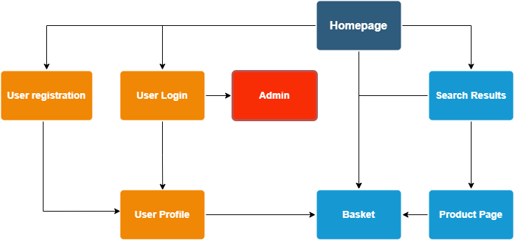

Responsive storyboard

## Homepage (Logged in) - Mobile

*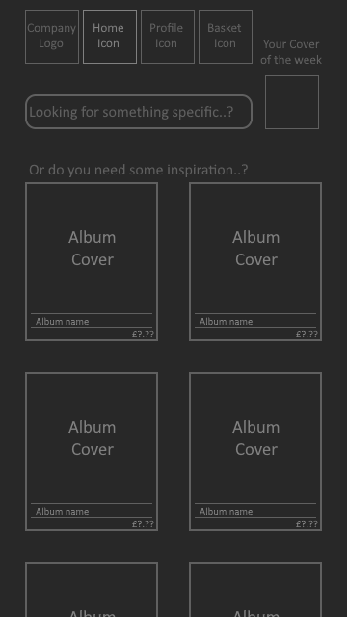*

## Homepage (Logged In) – Desktop

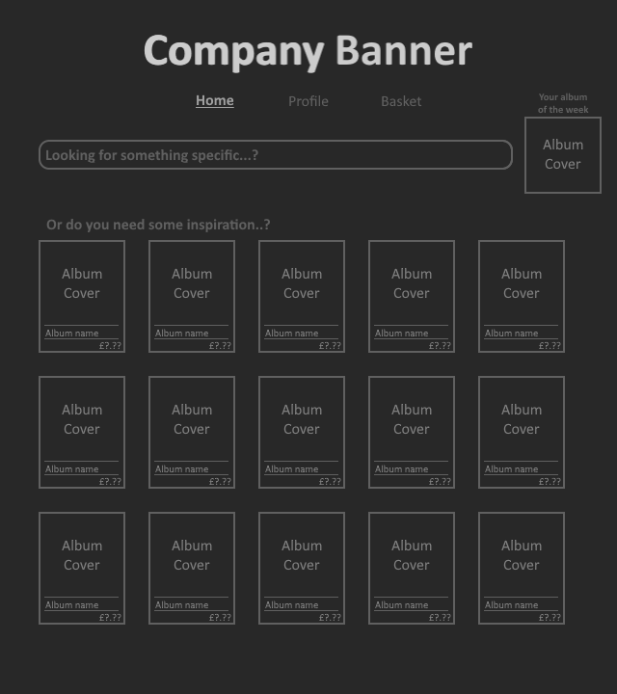

## Homepage (Logged Out) – Mobile

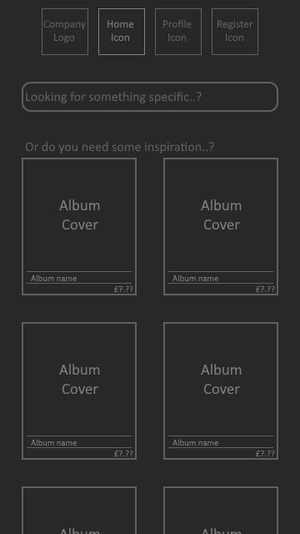

## Homepage (Logged Out) – Desktop

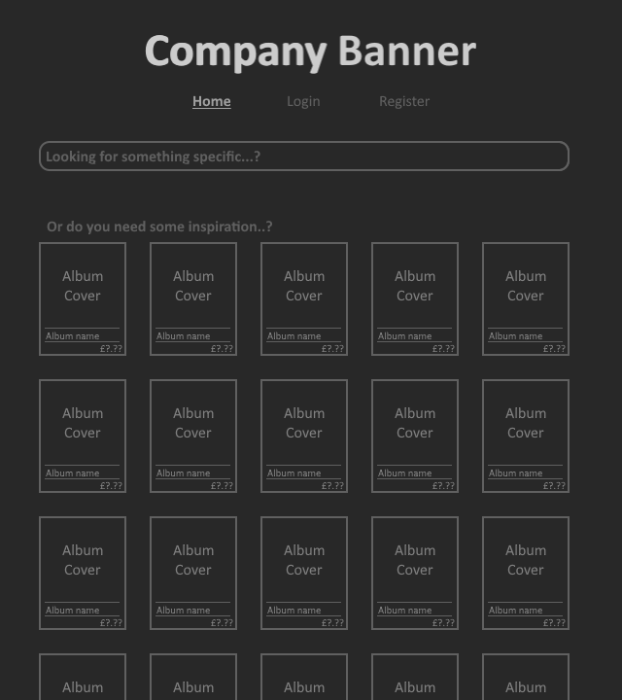

# Page summary/description

Homepage:

The home page will have the main company logo, some navigation links ((Login, Register)/(Profile, Basket) and Home) depending on if the user is logged in, a substantial search box and it will show a display of some random vinyl covers as well as displaying the users cover of the week if they have one selected otherwise the admin’s cover of the week. Its purpose is to enable the user to navigate wherever they want to go as easily as possible.

* At lower resolutions
  + The company banner is replaced with the company logo,
  + The common links are replaced with icons,
  + The cover images are reduced in size,
  + The company logo, common link icons and cover of the week text are all placed inline at the top of the page and,
  + The vinyl grid display will show fewer albums per row and at a certain limit will show 2 album covers per row.
* When the user searches their search will be passed via URL to the search page.
* The user (if logged in) may drag with a mouse or hold then drag with touch controls any album cover to their displayed cover of the week to update it. This will then update their album cover of the week in the database.

Register:

The registration page will have the main company logo, some navigation links (Login, Register and Home), a substantial search box, the registration form for new users to register as well as displaying the admin’s cover of the week. Its purpose is to enable the user to create an account so they can login and purchase/sell vinyls.

* At lower resolutions
  + The company banner is replaced with the company logo,
  + The common links are replaced with icons,
  + The cover images are reduced in size and,
  + The company logo and common link icons are placed inline at the top of the page.
* The user will be asked to confirm their password and the two entered passwords will be compared to ensure they are the same.
* The password will be hashed and salted (encrypted) before being stored in the database.
* A KeyEvent function will be registered on the address input that will capitalise the inputed address as it is being typed.
* When the user submits the form their input will be validated and Prepared Statements will be used to add the validated data to the database, creating a new user.
* Once the user has been successfully registered they will be redirected to their profile page.
* If a user is already logged in and tries to access the page they will be redirected to their profile page.
* When the user searches their search will be passed via URL to the search page.

Login:

The login page will have the main company logo, some navigation links (Login, Register and Home), a substantial search box, the login form for users to login as well as displaying the admin’s cover of the week. Its purpose is to enable the user to login so they can purchase/sell vinyls.

* At lower resolutions
  + The company banner is replaced with the company logo,
  + The common links are replaced with icons,
  + The cover images are reduced in size and,
  + The company logo, common link icons and cover of the week text are all placed inline at the top of the page.
* A KeyEvent function will be registered on the address input that will capitalise the input address as it is typed.
* The password will be encrypted using SHA-512 before being sent to the database.
* When the user submits the form their input will be validated by the database against information in the database and if they have supplied valid login information they will be logged in.
* Once the user has been successfully logged in, they will be redirected to their profile page.
* When the user searches their search will be passed via URL to the search page.
* If a user is already logged in and tries to access the page they will be redirected to their profile page.

Profile:

The profile page will have the main company logo, some navigation links (Profile, Basket and Home), a substantial search box, a welcome message, a logout link, a grid view of the vinyls on sale by the current user and it will show the users cover of the week if they have one selected otherwise the admin’s cover of the week. Its purpose is to enable the user to see their profile, browse vinyls they have up for sale and add/remove/update vinyls for sale.

* At lower resolutions
  + The company banner is replaced with the company logo,
  + The common links are replaced with icons,
  + The cover images are reduced in size,
  + The company logo, common link icons and cover of the week text are all placed inline at the top of the page and,
  + The vinyl grid display will show fewer albums per row and at a certain limit will show 2 album covers per row.
* A query will be sent to the database to retrieve all the vinyls the user is selling and these will be displayed in a grid layout.
* Clicking on the logout link will log the current user out and redirect the user to the login page.
* The user (if logged in) may drag with a mouse or hold then drag with touch controls any album cover to their displayed cover of the week to update it. This will then update their album cover of the week in the database.
* When the user searches their search will be passed via URL to the search page.

Search:

The search page will have the main company logo, some navigation links ((Login, Register/Profile, Basket) and Home depending on if the user is logged out/in), a substantial search box and it will show a display of some vinyl covers in a grid based on the search performed as well as displaying the users cover of the week if they have one selected otherwise the admin’s cover of the week. Its purpose is to enable the user to search for vinyls for sale on the website.

* At lower resolutions
  + The company banner is replaced with the company logo,
  + The common links are replaced with icons,
  + The cover images are reduced in size,
  + The company logo, common link icons and cover of the week text are all placed inline at the top of the page and,
  + The vinyl grid display will show fewer albums per row and at a certain limit will show 2 album covers per row,
* A query will be sent to the database to retrieve the vinyls that fit the search criteria provided in the URL link.
* Using the search bar on this page will send a new request to this page through the URL.
* The user (if logged in) may drag with a mouse or hold then drag with touch controls any album cover to their displayed cover of the week to update it. This will then update their album cover of the week in the database.

Product:

The product page will have the main company logo, some navigation links ((Login, Register/Profile, Basket) and Home depending on if the user is logged out/in), a substantial search box and it will show details about the specific album requested through the URL as well as displaying the users cover of the week if they have one selected otherwise the admin’s cover of the week. Its purpose is to display information about a specific vinyl for sale on the website and allow the person who is selling the vinyl to update the information about the vinyl if they are logged in.

* At lower resolutions
  + The company banner is replaced with the company logo,
  + The common links are replaced with icons,
  + The cover images are reduced in size and,
  + The company logo, common link icons and cover of the week text are all placed inline at the top of the page.
* A query will be sent to the database to retrieve information about the vinyl specified in the URL link.
* If the user is logged in and the vinyl is being sold by them then the values retrieved will be in modifiable text boxes and there will be an update button that allows them to update details about the vinyl.
* When the user submits the form their input will be validated and Prepared Statements will be used to add the validated data to the database, creating a new user.

Admin:

The admin page will have the main company logo, some navigation links (Profile, Basket and Home), a substantial search box, a logout link, a table of users on the website with buttons to delete or block these users and, it will show the admin’s cover of the week. Its purpose is to enable the admin to block or delete users as needed.

* At lower resolutions
  + The company banner is replaced with the company logo,
  + The common links are replaced with icons,
  + The cover images are reduced in size,
  + The company logo, common link icons and cover of the week text are all placed inline at the top of the page and,
  + The table scales to the viewport size as much as possible.
* When the admin presses the delete button on a user a query is run to delete that user and any vinyls they are selling from the database.

# Database table design & Data Dictionary

## ERD Design

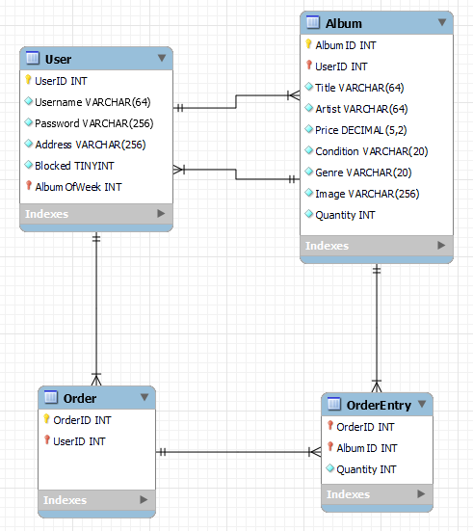

## Data Dictionary

|  |  |  |  |  |  |
| --- | --- | --- | --- | --- | --- |
| Table name: | | User | | | |
| Field name | Data type | Field Size | Auto Increment | Null | Comments |
| UserID | INT | default | YES | NO | Primary Key |
| Username | VARCHAR | 64 | NO | NO |  |
| Password | VARCHAR | 256 | NO | NO |  |
| Address | VASRCHAR | 256 | NO | NO |  |
| Blocked | BOOLEAN | default | NO | NO |  |
| AlbumOfWeek | INT | default | No | YES | Foreign Key – Album (AlbumID) |

|  |  |  |  |  |  |
| --- | --- | --- | --- | --- | --- |
| Table name: | | Album | | | |
| Field name | Data type | Field Size | Auto Increment | Null | Comments |
| AlbumID | INT | default | YES | NO | Primary Key |
| UserID | INT | default | NO | NO | Foreign Key |
| Title | VARCHAR | 64 | NO | NO |  |
| Artist | VARCHAR | 64 | NO | NO |  |
| Price | DECIMAL | (5,2) | NO | NO |  |
| Condition | VARCHAR | 20 | NO | NO |  |
| Genre | VARCHAR | 20 | NO | NO |  |
| Image | VARCHAR | 256 | NO | YES |  |
| Quantity | INT | default | NO | NO |  |

|  |  |  |  |  |  |
| --- | --- | --- | --- | --- | --- |
| Table name: | | Order | | | |
| Field name | Data type | Field Size | Auto Increment | Null | Comments |
| OrderID | INT | default | YES | NO | Primary Key |
| UserID | INT | default | NO | NO | Foreign Key |

|  |  |  |  |  |  |
| --- | --- | --- | --- | --- | --- |
| Table name: | | OrderEntry | | | |
| Field name | Data type | Field Size | Auto Increment | Null | Comments |
| OrderID | INT | default | NO | NO | Foreign Key, Primary Key |
| AlbumID | INT | default | NO | NO | Foreign Key, Primary Key |
| Quantity | INT | default | NO | NO |  |

# Test Strategy & Plan

## Test Strategy

There will be 4 stages to the testing process and the data from each stage will be contained in a separate table for neatness and easy reading. The 4 stages are:

* Testing of navigation per page, ensuring that all navigation links lead to the expected locations and submit data as expected where applicable.
* Testing of the functionality of every page in multiple browsers (Google Chrome, Mozilla Firefox and Microsoft Edge) to ensure that it behaves as intended on every page with every browser.
* Testing of the Responsiveness of the website on the iPhone 8 per page to ensure that the pages are functional and look as expected on the device and screen size.
* Testing of the Responsiveness of the website in multiple browsers (Google Chrome, Mozilla Firefox and Microsoft Edge) per page to ensure that the pages are functional and look as expected.

## Test Plan & results

|  |  |  |  |
| --- | --- | --- | --- |
| **Navigation Testing** | | | |
| Test Description | Expected Result | Actual Result | Action Taken |
| Home page -> Profile icon clicked (logged in) | Profile page loads | Profile page loads | No action needed. |
| Home page -> Profile icon clicked (logged out) | Login page loads | Login page loads | No action needed. |
| Home page -> Basket icon clicked (logged in) | Basket page loads | Basket page loads | No action needed. |
| Home page -> Register icon clicked (logged out) | Register page loads | Register page loads | No action needed. |
| Home page -> Home icon clicked | Home page reloads | Home page reloads | No action needed. |
| Home page -> Profile link clicked (logged in) | Profile page loads | Profile page loads | No action needed. |
| Home page -> Login link clicked (logged out) | Login page loads | Login page loads | No action needed. |
| Home page -> Basket link clicked (logged in) | Basket page loads | Basket page loads | No action needed. |
| Home page -> Register link clicked (logged out) | Register page loads | Register page loads | No action needed. |
| Home page -> Home link clicked | Home page reloads | Home page reloads | No action needed. |
| Login page -> Profile icon clicked | Login page reloads | Login page reloads | No action needed. |
| Login page -> Register icon clicked | Register page loads | Register page loads | No action needed. |
| Login page -> Home icon clicked | Home page loads | Home page loads | No action needed. |
| Login page -> Login link clicked | Login page reloads | Login page reloads | No action needed. |
| Login page -> Register link clicked | Register page loads | Register page loads | No action needed. |
| Login page -> Home link clicked | Home page loads | Home page loads | No action needed. |
| Register page -> Profile icon clicked | Login page loads | Login page loads | No action needed. |
| Register page -> Register icon clicked | Register page reloads | Register page reloads | No action needed. |
| Register page -> Home icon clicked | Home page loads | Home page loads | No action needed. |
| Register page -> Login link clicked | Login page loads | Login page loads | No action needed. |
| Register page -> Register link clicked | Register page reloads | Register page reloads | No action needed. |
| Register page -> Home link clicked | Home page loads | Home page loads | No action needed. |
| Search page -> Profile icon clicked (logged in) | Profile page loads | Profile page loads | No action needed. |
| Search page -> Profile icon clicked (logged out) | Login page loads | Login page loads | No action needed. |
| Search page -> Basket icon clicked (logged in) | Basket page loads | Basket page loads | No action needed. |
| Search page -> Register icon clicked (logged out) | Register page loads | Register page loads | No action needed. |
| Search page -> Home icon clicked | Home page loads | Home page loads | No action needed. |
| Search page -> Profile link clicked (logged in) | Profile page loads | Profile page loads | No action needed. |
| Search page -> Login link clicked (logged out) | Login page loads | Login page loads | No action needed. |
| Search page -> Basket link clicked (logged in) | Basket page loads | Basket page loads | No action needed. |
| Search page -> Register link clicked (logged out) | Register page loads | Register page loads | No action needed. |
| Search page -> Home link clicked | Home page loads | Home page loads | No action needed. |
| Profile page -> Profile icon clicked | Profile page reloads | Profile page reloads | No action needed. |
| Profile page -> Basket icon clicked | Basket page loads | Basket page loads | No action needed. |
| Profile page -> Home icon clicked | Home page loads | Home page loads | No action needed. |
| Profile page -> Profile link clicked | Profile page reloads | Profile page reloads | No action needed. |
| Profile page -> Basket link clicked | Basket page loads | Basket page loads | No action needed. |
| Profile page -> Home link clicked | Home page loads | Home page loads | No action needed. |
| Profile page -> Logout link clicked | User logged out and login page loads | User logged out and login page loads | No action needed. |
| Admin page -> Profile icon clicked | Admin page reloads | Admin page reloads | No action needed. |
| Admin page -> Basket icon clicked | Basket page loads | Basket page loads | No action needed. |
| Admin page -> Home icon clicked | Home page loads | Home page loads | No action needed. |
| Admin page -> Profile link clicked | Admin page reloads | Admin page reloads | No action needed. |
| Admin page -> Basket link clicked | Basket page loads | Basket page loads | No action needed. |
| Admin page -> Home link clicked | Home page loads | Home page loads | No action needed. |
| Admin page -> Logout link clicked | Admin logged out and login page loads | Admin logged out and login page loads | No action needed. |
| Basket page -> Profile icon clicked | Profile page loads | Profile page loads | No action needed. |
| Basket page -> Basket icon clicked | Basket page reloads | Basket page reloads | No action needed. |
| Basket page -> Home icon clicked | Home page loads | Home page loads | No action needed. |
| Basket page -> Profile link clicked | Profile page loads | Profile page loads | No action needed. |
| Basket page -> Basket link clicked | Basket page reloads | Basket page reloads | No action needed. |
| Basket page -> Home link clicked | Home page loads | Home page loads | No action needed. |

|  |  |  |  |
| --- | --- | --- | --- |
| **Webpage Functionality Testing** | | | |
| Test Description | Expected Result | Actual Result | Action Taken |
| Using Google Chrome I will load the homepage and attempt to search for albums using the search bar. | Search bar sends search and criteria to the search page through URL which performs the query required to return the requested results. | As expected. | No action needed. |
| Using Google Chrome I will load the homepage and check that the Album of the week display shows the correct album. | When logged in the album shown should be the album of the week set for the user in the database. If not logged in it should be the admin’s album of the week. | As expected. | No action needed. |
| Using Google Chrome I will load the homepage and check that dragging an Album Cover to the Album of the week display works as expected when logged in/out. | When logged in the album should visually change to the one that was dragged and the database should be updated so that the users Album of the week is set to the new album. When logged out dragging functionality should be disabled. | As expected. | No action needed. |
| Using the iPhone I will load the homepage and check that dragging an Album Cover to the Album of the week display works as expected when logged in/out. | When logged in the album should visually change to the one that was dragged and the database should be updated so that the users Album of the week is set to the new album. When logged out touch-drag functionality should be disabled. | As expected. | No action needed. |
| Using Mozilla Firefox I will load the homepage and attempt to search for albums using the search bar. | Search bar sends search and criteria to the search page through URL which performs the query required to return the requested results. | As expected. | No action needed. |
| Using Mozilla Firefox I will load the homepage and check that the Album of the week display shows the correct album. | When logged in the album shown should be the album of the week set for the user in the database. If not logged in it should be the admin’s album of the week. | As expected. | No action needed. |
| Using Mozilla Firefox I will load the homepage and check that dragging an Album Cover to the Album of the week display works as expected when logged in/out. | When logged in the album should visually change to the one that was dragged and the database should be updated so that the users Album of the week is set to the new album. When logged out dragging functionality should be disabled. | The Album of the week cover disappears, and the database doesn’t update. | No solution found yet. |
| Using Microsoft Edge I will load the homepage and attempt to search for albums using the search bar. | Search bar sends search and criteria to the search page through URL which performs the query required to return the requested results. | As expected. | No action needed. |
| Using Microsoft Edge I will load the homepage and check that the Album of the week display shows the correct album. | When logged in the album shown should be the album of the week set for the user in the database. If not logged in it should be the admin’s album of the week. | As expected. | No action needed. |
| Using Microsoft Edge I will load the homepage and check that dragging an Album Cover to the Album of the week display works as expected when logged in/out. | When logged in the album should visually change to the one that was dragged and the database should be updated so that the users Album of the week is set to the new album. When logged out dragging functionality should be disabled. | As expected. | No action needed. |
| Using Google Chrome I will load the register page and attempt to search for albums using the search bar. | Search bar sends search and criteria to the search page through URL which performs the query required to return the requested results. | As expected. | No action needed. |
| Using Google Chrome I will load the register page and check that the Album of the week display shows the correct album. | The album shown should be the album of the week set for the admin in the database. | As expected. | No action needed. |
| Using Google Chrome I will load the register page and attempt to register a user with valid information. | The user is created in the database, logged in and the browser is redirected to the profile page. | As expected. | No action needed. |
| Using Google Chrome I will load the register page and attempt to register a user with invalid information. | The user is not created and a useful error message is displayed. | As expected. | No action needed. |
| Using Mozilla Firefox I will load the register page and attempt to search for albums using the search bar. | Search bar sends search and criteria to the search page through URL which performs the query required to return the requested results. | As expected. | No action needed. |
| Using Mozilla Firefox I will load the register page and check that the Album of the week display shows the correct album. | The album shown should be the album of the week set for the admin in the database. | As expected. | No action needed. |
| Using Mozilla Firefox I will load the register page and attempt to register a user with valid information. | The user is created in the database, logged in and the browser is redirected to the profile page. | As expected. | No action needed. |
| Using Mozilla Firefox I will load the register page and attempt to register a user with invalid information. | The user is not created and a useful error message is displayed. | As expected. | No action needed. |
| Using Microsoft Edge I will load the register page and attempt to search for albums using the search bar. | Search bar sends search and criteria to the search page through URL which performs the query required to return the requested results. | As expected. | No action needed. |
| Using Microsoft Edge I will load the register page and check that the Album of the week display shows the correct album. | The album shown should be the album of the week set for the admin in the database. | As expected. | No action needed. |
| Using Microsoft Edge I will load the register page and attempt to register a user with valid information. | The user is created in the database, logged in and the browser is redirected to the profile page. | As expected. | No action needed. |
| Using Microsoft Edge I will load the register page and attempt to register a user with invalid information. | The user is not created and a useful error message is displayed. | As expected. | No action needed. |
| Using Google Chrome I will load the login page and attempt to search for albums using the search bar. | Search bar sends search and criteria to the search page through URL which performs the query required to return the requested results. | As expected. | No action needed. |
| Using Google Chrome I will load the login page and check that the Album of the week display shows the correct album. | The album shown should be the album of the week set for the admin in the database. | As expected. | No action needed. |
| Using Google Chrome I will load the login page and attempt to log in using valid credentials. | The user is logged in and the browser is redirected to the profile page. | As expected. | No action needed. |
| Using Google Chrome I will load the login page and attempt to log in using valid admin credentials. | The admin is logged in and the browser is redirected to the admin page. | As expected. | No action needed. |
| Using Google Chrome I will load the login page and attempt to log in using invalid information. | The user is not logged in and a useful error message is displayed. | As expected. | No action needed. |
| Using Mozilla Firefox I will load the login page and attempt to search for albums using the search bar. | Search bar sends search and criteria to the search page through URL which performs the query required to return the requested results. | As expected. | No action needed. |
| Using Mozilla Firefox I will load the login page and check that the Album of the week display shows the correct album. | The album shown should be the album of the week set for the admin in the database. | As expected. | No action needed. |
| Using Mozilla Firefox I will load the login page and attempt to log in using valid credentials. | The user is logged in and the browser is redirected to the profile page. | As expected. | No action needed. |
| Using Mozilla Firefox I will load the login page and attempt to log in using valid admin credentials. | The admin is logged in and the browser is redirected to the admin page. | As expected. | No action needed. |
| Using Mozilla Firefox I will load the login page and attempt to log in using invalid information. | The user is not logged in and a useful error message is displayed. | As expected. | No action needed. |
| Using Microsoft Edge I will load the login page and attempt to search for albums using the search bar. | Search bar sends search and criteria to the search page through URL which performs the query required to return the requested results. | As expected. | No action needed. |
| Using Microsoft Edge I will load the login page and check that the Album of the week display shows the correct album. | The album shown should be the album of the week set for the admin in the database. | As expected. | No action needed. |
| Using Microsoft Edge I will load the login page and attempt to log in using valid credentials. | The user is logged in and the browser is redirected to the profile page. | As expected. | No action needed. |
| Using Microsoft Edge I will load the login page and attempt to log in using valid admin credentials. | The admin is logged in and the browser is redirected to the admin page. | As expected. | No action needed. |
| Using Microsoft Edge I will load the login page and attempt to log in using invalid information. | The user is not logged in and a useful error message is displayed. | As expected. | No action needed. |
| Using Google Chrome I will attempt to load the profile page while logged out | The profile page will redirect the browser to the login page. | As expected. | No action needed. |
| Using Google Chrome I will login to the profile page and attempt to search for albums using the search bar. | Search bar sends search and criteria to the search page through URL which performs the query required to return the requested results. | As expected. | No action needed. |
| Using Google Chrome I will login to the profile page and check that the Album of the week display shows the correct album. | The album shown should be the album of the week set for the logged in user in the database if one is set otherwise it will be a question mark image. | As expected. | No action needed. |
| Using Google Chrome I will login to the profile page and use the logout link to log out. | The user is logged out and the browser is redirected to the login page. | As expected. | No action needed. |
| Using Mozilla Firefox I will attempt to load the profile page while logged out | The profile page will redirect the browser to the login page. | As expected. | No action needed. |
| Using Mozilla Firefox I will login to the profile page and attempt to search for albums using the search bar. | Search bar sends search and criteria to the search page through URL which performs the query required to return the requested results. | As expected. | No action needed. |
| Using Mozilla Firefox I will login to the profile page and check that the Album of the week display shows the correct album. | The album shown should be the album of the week set for the logged in user in the database if one is set otherwise it will be a question mark image. | As expected. | No action needed. |
| Using Mozilla Firefox I will login to the profile page and use the logout link to log out. | The user is logged out and the browser is redirected to the login page. | As expected. | No action needed. |
| Using Microsoft Edge I will attempt to load the profile page while logged out | The profile page will redirect the browser to the login page. | As expected. | No action needed. |
| Using Microsoft Edge I will login to the profile page and attempt to search for albums using the search bar. | Search bar sends search and criteria to the search page through URL which performs the query required to return the requested results. | As expected. | No action needed. |
| Using Microsoft Edge I will login to the profile page and check that the Album of the week display shows the correct album. | The album shown should be the album of the week set for the logged in user in the database if one is set otherwise it will be a question mark image. | As expected. | No action needed. |
| Using Microsoft Edge I will login to the profile page and use the logout link to log out. | The user is logged out and the browser is redirected to the login page. | As expected. | No action needed. |
| Using Google Chrome I will load the search page and attempt to search for albums using the search bar. | The search bar sends search and criteria back to itself through URL and performs the query showing the requested results in a grid. | As expected. | No action needed. |
| Using Google Chrome I will load the search page and check that the Album of the week display shows the correct album. | The album shown should be the album of the week set for the logged in user in the database otherwise it should be the admin’s album of the week. | As expected. | No action needed. |
| Using Google Chrome I will load the search page, perform a search and check that dragging an Album Cover to the Album of the week display works as expected when logged in/out. | When logged in the album should visually change to the one that was dragged and the database should be updated so that the users album of the week is set to the new album. When logged out dragging functionality should be disabled. | As expected. | No action needed. |
| Using the iPhone I will load the search page, perform a search and check that dragging an Album Cover to the Album of the week display works as expected when logged in/out. | When logged in the album should visually change to the one that was dragged and the database should be updated so that the users album of the week is set to the new album. When logged out touch-drag functionality should be disabled. | As expected. | No action needed. |
| Using Mozilla Firefox I will load the search page and attempt to search for albums using the search bar. | The search bar sends search and criteria back to itself through URL and performs the query showing the requested results in a grid. | As expected. | No action needed. |
| Using Mozilla Firefox I will load the search page and check that the Album of the week display shows the correct album. | The album shown should be the album of the week set for the logged in user in the database otherwise it should be the admin’s album of the week. | As expected. | No action needed. |
| Using Mozilla Firefox I will load the search page, perform a search and check that dragging an Album Cover to the Album of the week display works as expected when logged in/out. | When logged in the album should visually change to the one that was dragged and the database should be updated so that the users album of the week is set to the new album. When logged out dragging functionality should be disabled. | The Album of the week cover disappears, and the database doesn’t update. | No solution found yet. |
| Using Microsoft Edge I will load the search page and attempt to search for albums using the search bar. | The search bar sends search and criteria back to itself through URL and performs the query showing the requested results in a grid. | As expected. | No action needed. |
| Using Microsoft Edge I will load the search page and check that the Album of the week display shows the correct album. | The album shown should be the album of the week set for the logged in user in the database otherwise it should be the admin’s album of the week. | As expected. | No action needed. |
| Using Microsoft Edge I will load the search page, perform a search and check that dragging an Album Cover to the Album of the week display works as expected when logged in/out. | When logged in the album should visually change to the one that was dragged and the database should be updated so that the users album of the week is set to the new album. When logged out dragging functionality should be disabled. | As expected. | No action needed. |
| Using Google Chrome I will attempt to load the admin page while logged out | The admin page will redirect the browser to the login page. | As expected. | No action needed. |
| Using Google Chrome I will attempt to load the admin page while logged in as a normal user | The admin page will redirect the browser to the login page. | As expected. | No action needed. |
| Using Google Chrome I will login to the admin page and attempt to search for albums using the search bar. | Search bar sends search and criteria to the search page through URL which performs the query required to return the requested results. | As expected. | No action needed. |
| Using Google Chrome I will login to the admin page and check that the Album of the week display shows the correct album. | The album shown should be the album of the week set for the admin in the database. | As expected. | No action needed. |
| Using Google Chrome I will login to the admin page and use the logout link to log out. | The user is logged out and the browser is redirected to the login page. | As expected. | No action needed. |
| Using Google Chrome I will login to the admin page and use the block button on a user to block them from logging in. | A query is run to set a flag in the database for the user which prevents them from logging in. | As expected. | No action needed. |
| Using Google Chrome I will login to the admin page and use the delete button on a user to delete their account from the database. | A query is run to remove the user and all data they own from the database. | As expected. | No action needed. |
| Using Mozilla Firefox I will attempt to load the admin page while logged out | The admin page will redirect the browser to the login page. | As expected. | No action needed. |
| Using Mozilla Firefox I will attempt to load the admin page while logged in as a normal user | The admin page will redirect the browser to the login page. | As expected. | No action needed. |
| Using Mozilla Firefox I will login to the admin page and attempt to search for albums using the search bar. | Search bar sends search and criteria to the search page through URL which performs the query required to return the requested results. | As expected. | No action needed. |
| Using Mozilla Firefox I will login to the admin page and check that the Album of the week display shows the correct album. | The album shown should be the album of the week set for the admin in the database. | As expected. | No action needed. |
| Using Mozilla Firefox I will login to the admin page and use the logout link to log out. | The user is logged out and the browser is redirected to the login page. | As expected. | No action needed. |
| Using Mozilla Firefox I will login to the admin page and use the block button on a user to block them from logging in. | A query is run to set a flag in the database for the user which prevents them from logging in. | As expected. | No action needed. |
| Using Mozilla Firefox I will login to the admin page and use the delete button on a user to delete their account from the database. | A query is run to remove the user and all data they own from the database. | As expected. | No action needed. |
| Using Microsoft Edge I will attempt to load the admin page while logged out | The admin page will redirect the browser to the login page. | As expected. | No action needed. |
| Using Microsoft Edge I will attempt to load the admin page while logged in as a normal user | The admin page will redirect the browser to the login page. | As expected. | No action needed. |
| Using Microsoft Edge I will login to the admin page and attempt to search for albums using the search bar. | Search bar sends search and criteria to the search page through URL which performs the query required to return the requested results. | As expected. | No action needed. |
| Using Microsoft Edge I will login to the admin page and check that the Album of the week display shows the correct album. | The album shown should be the album of the week set for the admin in the database. | As expected. | No action needed. |
| Using Microsoft Edge I will login to the admin page and use the logout link to log out. | The user is logged out and the browser is redirected to the login page. | As expected. | No action needed. |
| Using Microsoft Edge I will login to the admin page and use the block button on a user to block them from logging in. | A query is run to set a flag in the database for the user which prevents them from logging in. | As expected. | No action needed. |
| Using Microsoft Edge I will login to the admin page and use the delete button on a user to delete their account from the database. | A query is run to remove the user and all data they own from the database. | As expected. | No action needed. |

|  |  |  |  |
| --- | --- | --- | --- |
| **Responsiveness Testing – iPhone 8 Plus** | | | |
| Test Description | Expected Result | Actual Result | Action Taken |
| I will load the homepage on the device and check that all elements have scaled properly. | All elements have scaled properly. | All elements have scaled properly. | No action needed. |
| I will load the homepage on the device and check that it is readable and looks as expected on the devices. | The page is readable and looks as expected on the device. | The page is readable and looks as expected on the device. | No action needed. |
| I will load the login page on the device and check that all elements have scaled properly. | All elements have scaled properly. | All elements have scaled properly. | No action needed. |
| I will load the login page on the device and check that it is readable and looks as expected on the devices. | The page is readable and looks as expected on the device. | The page is readable and looks as expected on the device. | No action needed. |
| I will load the register page on the device and check that all elements have scaled properly. | All elements have scaled properly. | All elements have scaled properly. | No action needed. |
| I will load the register page on the device and check that it is readable and looks as expected on the devices. | The page is readable and looks as expected on the device. | The page is readable and looks as expected on the device. | No action needed. |
| I will load the profile page on the device and check that all elements have scaled properly. | All elements have scaled properly. | All elements have scaled properly. | No action needed. |
| I will load the profile page on the device and check that it is readable and looks as expected on the devices. | The page is readable and looks as expected on the device. | The page is readable and looks as expected on the device. | No action needed. |
| I will load the search page on the device and check that all elements have scaled properly. | All elements have scaled properly. | All elements have scaled properly. | No action needed. |
| I will load the search page on the device and check that it is readable and looks as expected on the devices. | The page is readable and looks as expected on the device. | The page is readable and looks as expected on the device. | No action needed. |
| I will load the admin page on the device and check that all elements have scaled properly. | All elements have scaled properly. | All elements have scaled properly. | No action needed. |
| I will load the admin page on the device and check that it is readable and looks as expected on the devices. | The page is readable and looks as expected on the device. | The page is readable and looks as expected on the device. | No action needed. |

|  |  |  |  |
| --- | --- | --- | --- |
| **Responsiveness Testing – Browsers** | | | |
| Test Description | Expected Result | Actual Result | Action Taken |
| I will load the homepage in Google Chrome and check that all elements scale properly when the window is resized to be larger and smaller. | All elements scale properly. | All elements scale properly. | No action needed. |
| I will load the homepage in Google Chrome and check that it is readable and looks as expected when the window is resized to be larger and smaller. | The page is readable and looks as expected. | The page is readable and looks as expected. | No action needed. |
| I will load the login page in Google Chrome and check that all elements scale properly when the window is resized to be larger and smaller. | All elements scale properly. | All elements scale properly. | No action needed. |
| I will load the login page in Google Chrome and check that it is readable and looks as expected when the window is resized to be larger and smaller. | The page is readable and looks as expected. | The page is readable and looks as expected. | No action needed. |
| I will load the register page in Google Chrome and check that all elements scale properly when the window is resized to be larger and smaller. | All elements scale properly. | All elements scale properly. | No action needed. |
| I will load the register page in Google Chrome and check that it is readable and looks as expected when the window is resized to be larger and smaller. | The page is readable and looks as expected. | The page is readable and looks as expected. | No action needed. |
| I will load the profile in Google Chrome and check that all elements scale properly when the window is resized to be larger and smaller. | All elements scale properly. | All elements scale properly. | No action needed. |
| I will load the profile page in Google Chrome and check that it is readable and looks as expected when the window is resized to be larger and smaller. | The page is readable and looks as expected. | The page is readable and looks as expected. | No action needed. |
| I will load the search page in Google Chrome and check that all elements scale properly when the window is resized to be larger and smaller. | All elements scale properly. | All elements scale properly. | No action needed. |
| I will load the search page in Google Chrome and check that it is readable and looks as expected when the window is resized to be larger and smaller. | The page is readable and looks as expected. | The page is readable and looks as expected. | No action needed. |
| I will load the admin page in Google Chrome and check that all elements scale properly when the window is resized to be larger and smaller. | All elements scale properly. | All elements scale properly. | No action needed. |
| I will load the admin page in Google Chrome and check that it is readable and looks as expected when the window is resized to be larger and smaller. | The page is readable and looks as expected. | The page is readable and looks as expected. | No action needed. |
| I will load the homepage in Mozilla Firefox and check that all elements scale properly when the window is resized to be larger and smaller. | All elements scale properly. | All elements scale properly. | No action needed. |
| I will load the homepage in Mozilla Firefox and check that it is readable and looks as expected when the window is resized to be larger and smaller. | The page is readable and looks as expected. | The page is readable and looks as expected. | No action needed. |
| I will load the login page in Mozilla Firefox and check that all elements scale properly when the window is resized to be larger and smaller. | All elements scale properly. | All elements scale properly. | No action needed. |
| I will load the login page in Mozilla Firefox and check that it is readable and looks as expected when the window is resized to be larger and smaller. | The page is readable and looks as expected. | The page is readable and looks as expected. | No action needed. |
| I will load the register page in Mozilla Firefox and check that all elements scale properly when the window is resized to be larger and smaller. | All elements scale properly. | All elements scale properly. | No action needed. |
| I will load the register page in Mozilla Firefox and check that it is readable and looks as expected when the window is resized to be larger and smaller. | The page is readable and looks as expected. | The page is readable and looks as expected. | No action needed. |
| I will load the profile page in Mozilla Firefox and check that all elements scale properly when the window is resized to be larger and smaller. | All elements scale properly. | All elements scale properly. | No action needed. |
| I will load the profile page in Mozilla Firefox and check that it is readable and looks as expected when the window is resized to be larger and smaller. | The page is readable and looks as expected. | The page is readable and looks as expected. | No action needed. |
| I will load the search page in Mozilla Firefox and check that all elements scale properly when the window is resized to be larger and smaller. | All elements scale properly. | All elements scale properly. | No action needed. |
| I will load the search page in Mozilla Firefox and check that it is readable and looks as expected when the window is resized to be larger and smaller. | The page is readable and looks as expected. | The page is readable and looks as expected. | No action needed. |
| I will load the admin page in Mozilla Firefox and check that all elements scale properly when the window is resized to be larger and smaller. | All elements scale properly. | All elements scale properly. | No action needed. |
| I will load the admin page in Mozilla Firefox and check that it is readable and looks as expected when the window is resized to be larger and smaller. | The page is readable and looks as expected. | The page is readable and looks as expected. | No action needed. |
| I will load the homepage in Microsoft Edge and check that all elements scale properly when the window is resized to be larger and smaller. | All elements scale properly. | All elements scale properly. | No action needed. |
| I will load the homepage in Microsoft Edge and check that it is readable and looks as expected when the window is resized to be larger and smaller. | The page is readable and looks as expected. | The page is readable and looks as expected. | No action needed. |
| I will load the login page in Microsoft Edge and check that all elements scale properly when the window is resized to be larger and smaller. | All elements scale properly. | All elements scale properly. | No action needed. |
| I will load the login page in Microsoft Edge and check that it is readable and looks as expected when the window is resized to be larger and smaller. | The page is readable and looks as expected. | The page is readable and looks as expected. | No action needed. |
| I will load the register page in Microsoft Edge and check that all elements scale properly when the window is resized to be larger and smaller. | All elements scale properly. | All elements scale properly. | No action needed. |
| I will load the register page in Microsoft Edge and check that it is readable and looks as expected when the window is resized to be larger and smaller. | The page is readable and looks as expected. | The page is readable and looks as expected. | No action needed. |
| I will load the profile in Microsoft Edge and check that all elements scale properly when the window is resized to be larger and smaller. | All elements scale properly. | All elements scale properly. | No action needed. |
| I will load the profile page in Microsoft Edge and check that it is readable and looks as expected when the window is resized to be larger and smaller. | The page is readable and looks as expected. | The page is readable and looks as expected. | No action needed. |
| I will load the search page Microsoft Edge and check that all elements scale properly when the window is resized to be larger and smaller. | All elements scale properly. | All elements scale properly. | No action needed. |
| I will load the search page in Microsoft Edge and check that it is readable and looks as expected when the window is resized to be larger and smaller. | The page is readable and looks as expected. | The page is readable and looks as expected. | No action needed. |
| I will load the admin page in Microsoft Edge and check that all elements scale properly when the window is resized to be larger and smaller. | All elements scale properly. | All elements scale properly. | No action needed. |
| I will load the admin page in Microsoft Edge and check that it is readable and looks as expected when the window is resized to be larger and smaller. | The page is readable and looks as expected. | The page is readable and looks as expected. | No action needed. |